# EDUCATION

## Bachelor of Science

### SRM ARTS AND SCIENCE COLLEGE

*07/2017 - 09/2020*, *6.2*

# SKILLS

Manual Testing

Test cases

Test Data

Selenium WebDriver

JIRA

Core Java

My SQL

# TRAINING EXPERIENCE

Test Scenario

Automation Testing

## Software Tester (Junior) / Automation Tester

### TESTLEAF SOFTWARE

*02/2022 - 03/2022*,

*Project: ServiceNow ITSM Application Achievements/Tasks*

Understand ServiceNow application requirements (JIRA)

Identify the test cases to be automated

Develop 40+ automated script using Selenium WebDriver in java

Execute the automated tests against chrome and ﬁrefox Create defect for the failed tests in JIRA

Provide test reports for all executed tests Attend meetings with test and dev teams

*Contact : Babu,Hari*

# PERSONAL PROJECTS

Salesforce CRM Application (01/2022 - 02/2022)

Identiﬁed edge test cases during exploratory testing Awarded as best tester during training period

ServiceNow ITSM Application (02/2022 - 03/2022)

Automated more than 40 tests Executed both in chrome and ﬁrefox

# CERTIFICATES

Certiﬁed Software Test Engineer from TestLeaf (01/2022 - 03/2022)

# LANGUAGES

English

*Full Professional Proﬁciency*

Tamil

*Native or Bilingual Proﬁciency*

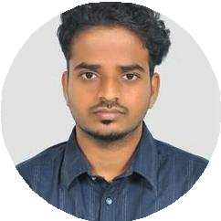

Chennai, India

+91 9499962740

[nireshkumar.madhanagopal@gmail.com](mailto:nireshkumar.madhanagopal@gmail.com)

Niresh Kumar

Incoming Software Engineer

2020 Fresh graduate trained in core java with good quality communication and problem solving skills, looking forward for software engineering job.

Telugu

*Professional Working Proﬁciency*

# INTERESTS

Gaming

Films

Pet Care